AgileSoft Inventory Management System

Document Status : DRAFT
Prepared By : Vishal Arora
Reviewer : Agile Soft Systems, Inc.
Developer : Agile Soft Systems, Inc.

1 Purpose

2 Overview (Introduction)

3 Requirements

4 Objective

5 Application Users

6 Proposed Technologies

7 User Interface Design

7.1 Login GUI

7.2 Admin Panel

7.3 Simple User Screen

1)Purpose

Purpose of this document to state the details of all design and development components involved in
Agile Soft Systems Inventory Management System.

2)Overview

It is a web based application which allows user management as well as inventory management for Agile Soft Systems, Inc.

3)Requirements

The proposed system must meet the following requirements of Agile Soft Systems, Inc. :
1. Sensitive information like email id and password should not be exposed to any other user
2. Admin must have all the rights related to User, Items and Requests generated by simple user
3. Simple User must have option of making request for the required item

4)Objective

The objective of this project is to provide user management and inventory management of the organization. If any user request for any item then that request should be recorded and appropriate response must be generated.

5)Application User

There will be two types of application users are available in the system

1)Admin
- It is the root user who can add/view simple user in the system
- There will be only one system admin configured in the system initially
- Admin can also add items details in the system
- Admin can also view all the requests made by simple user and accordingly give response to simple user.
- Response for the request can be Declined(0), Approved(1) or Pending(2) and generating the mail thereby.

2)Simple User
- Simple user can view his/her profile
- Can request for the item
- Initially request status will be pending

6)Proposed Technologies

For this system we have used the following technologies,
HTML, CSS, Bootstap, Jquery, javascript, Java and MySql

7) User Interface Design

7.1 Login GUI

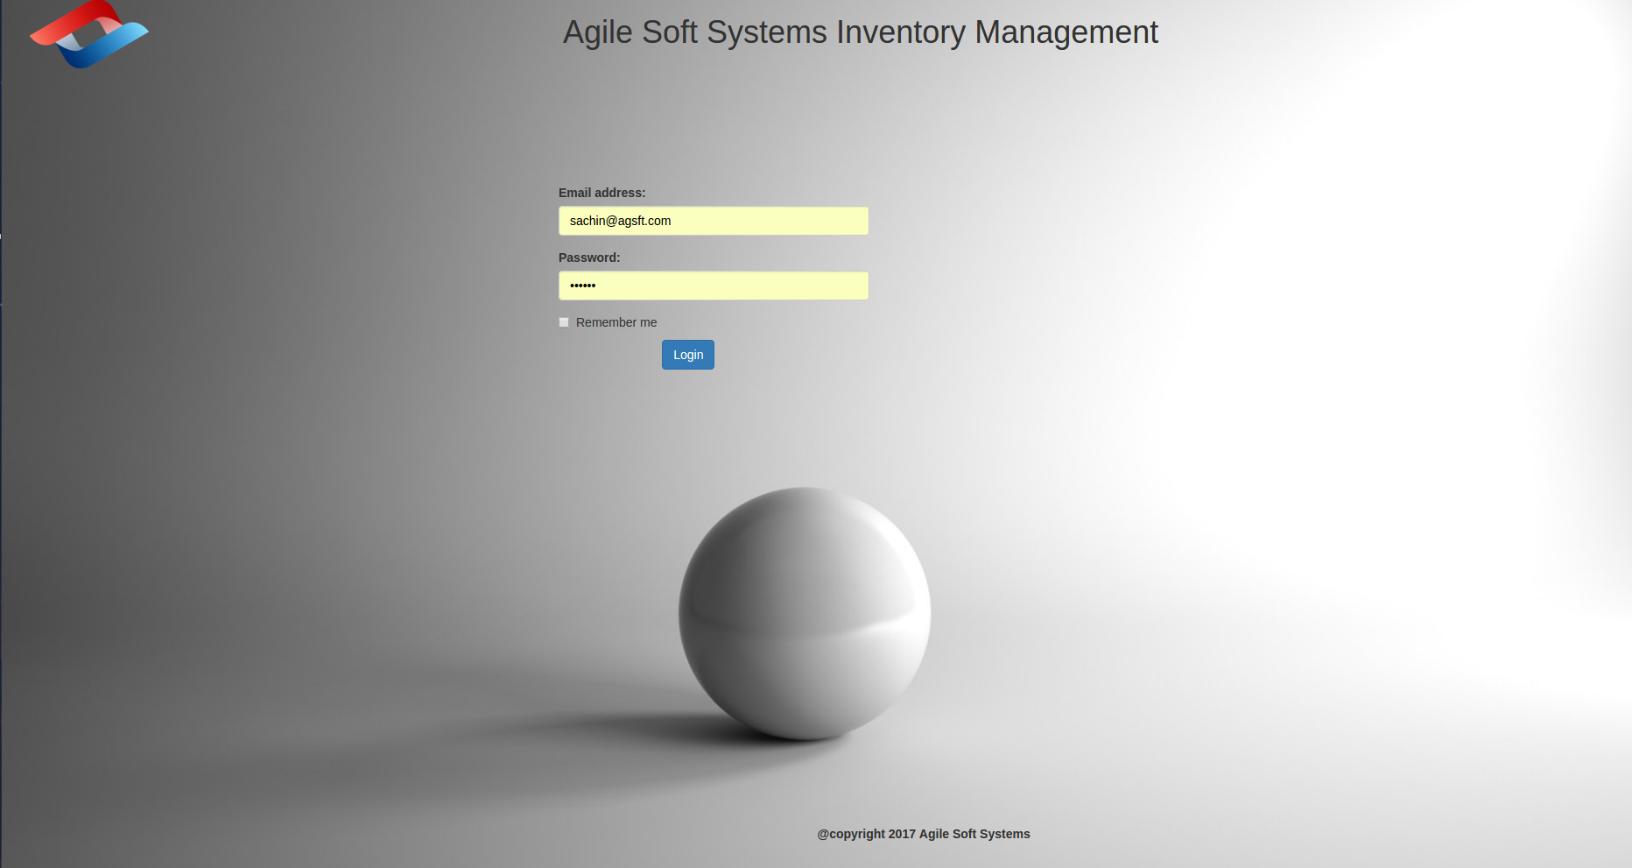

7.2 Admin Panel – Inventory List

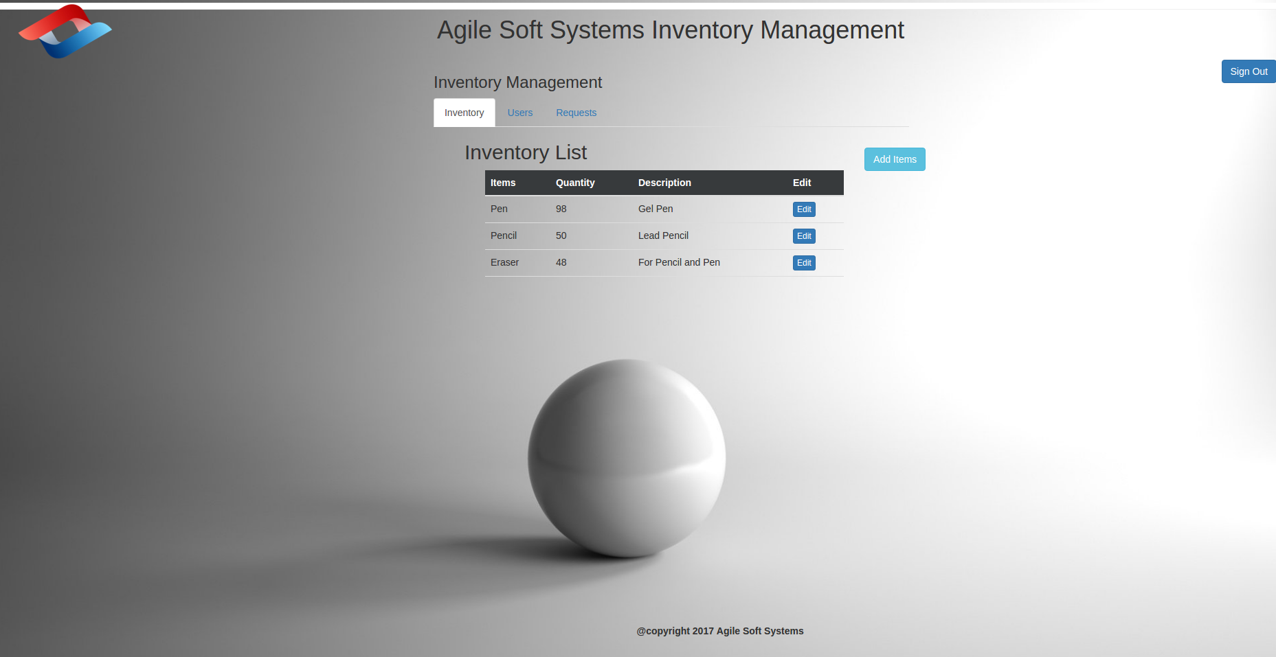

7.3 Admin Panel – Add New Inventory

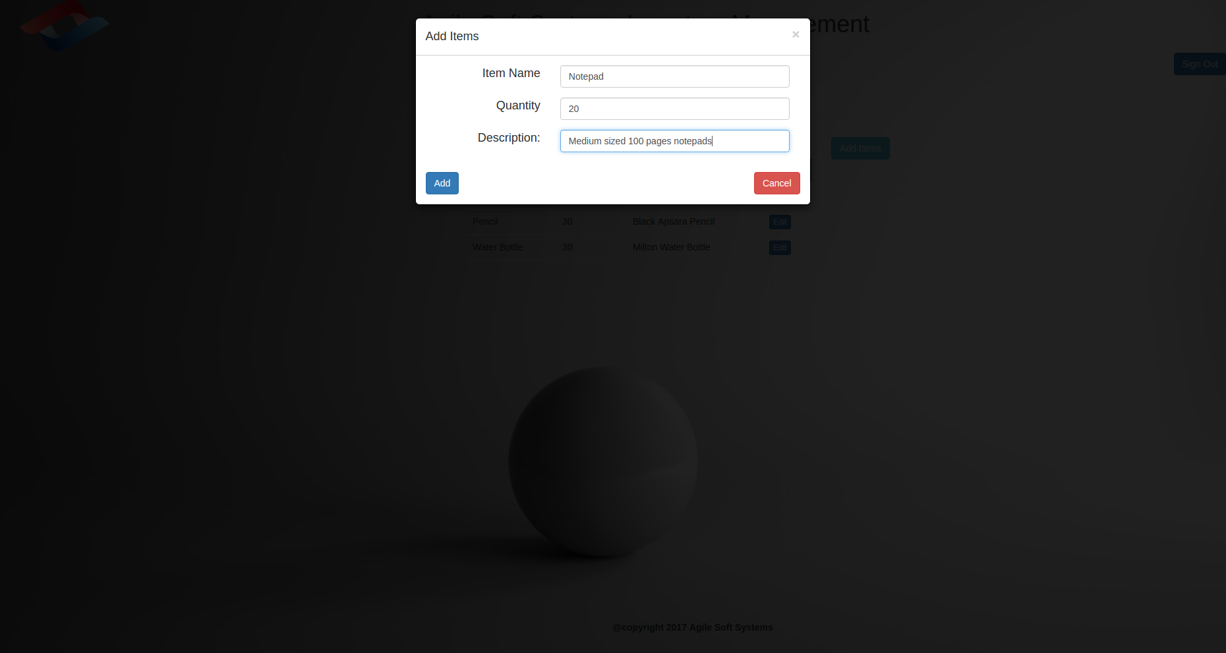

7.4 Admin Panel – Users List

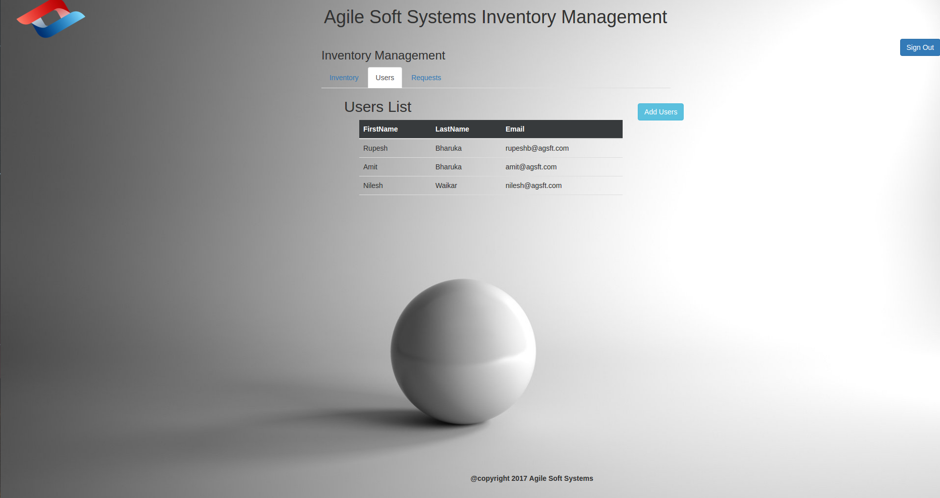

7.5 Admin Panel – Add New User

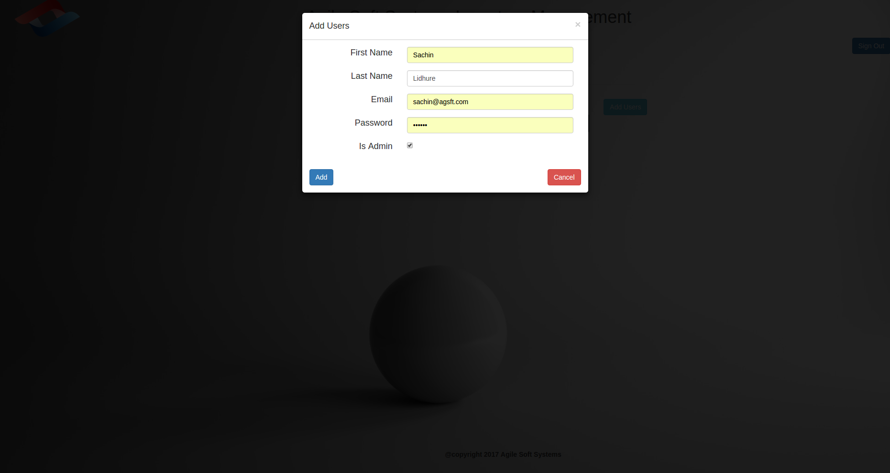

7.6 Admin Panel – Pending Request List

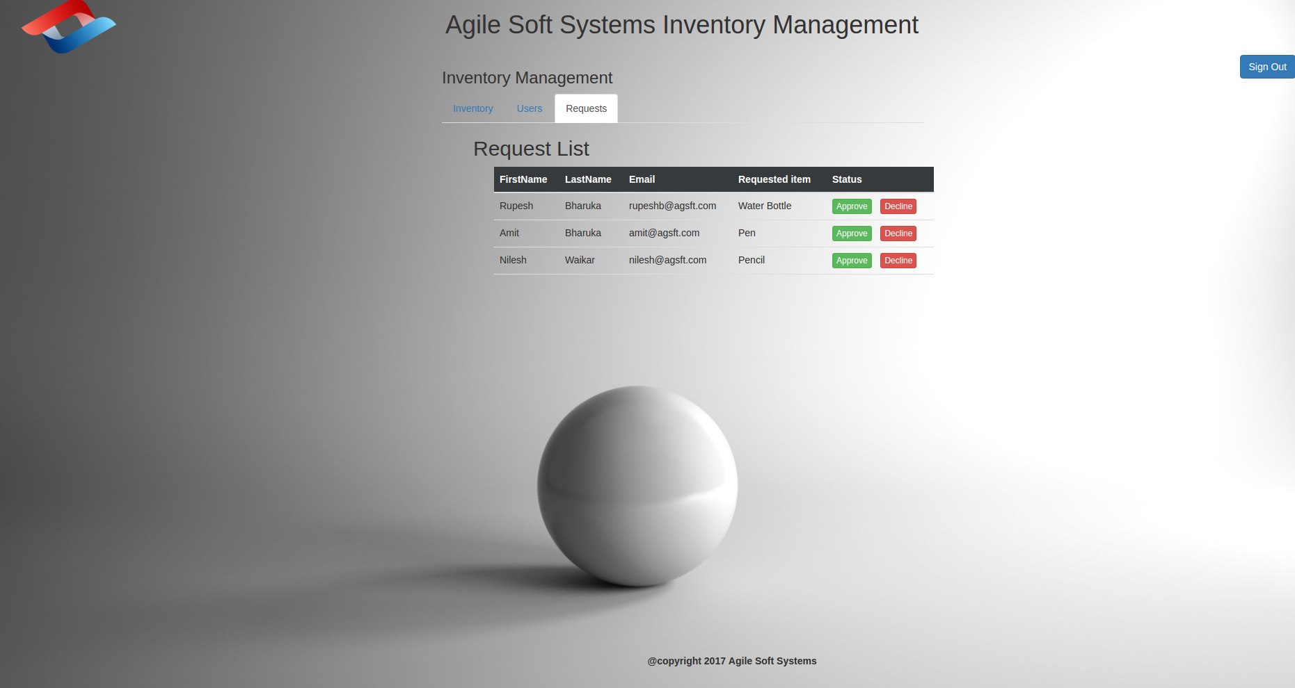

7.7 Admin Panel – Approve/Reject

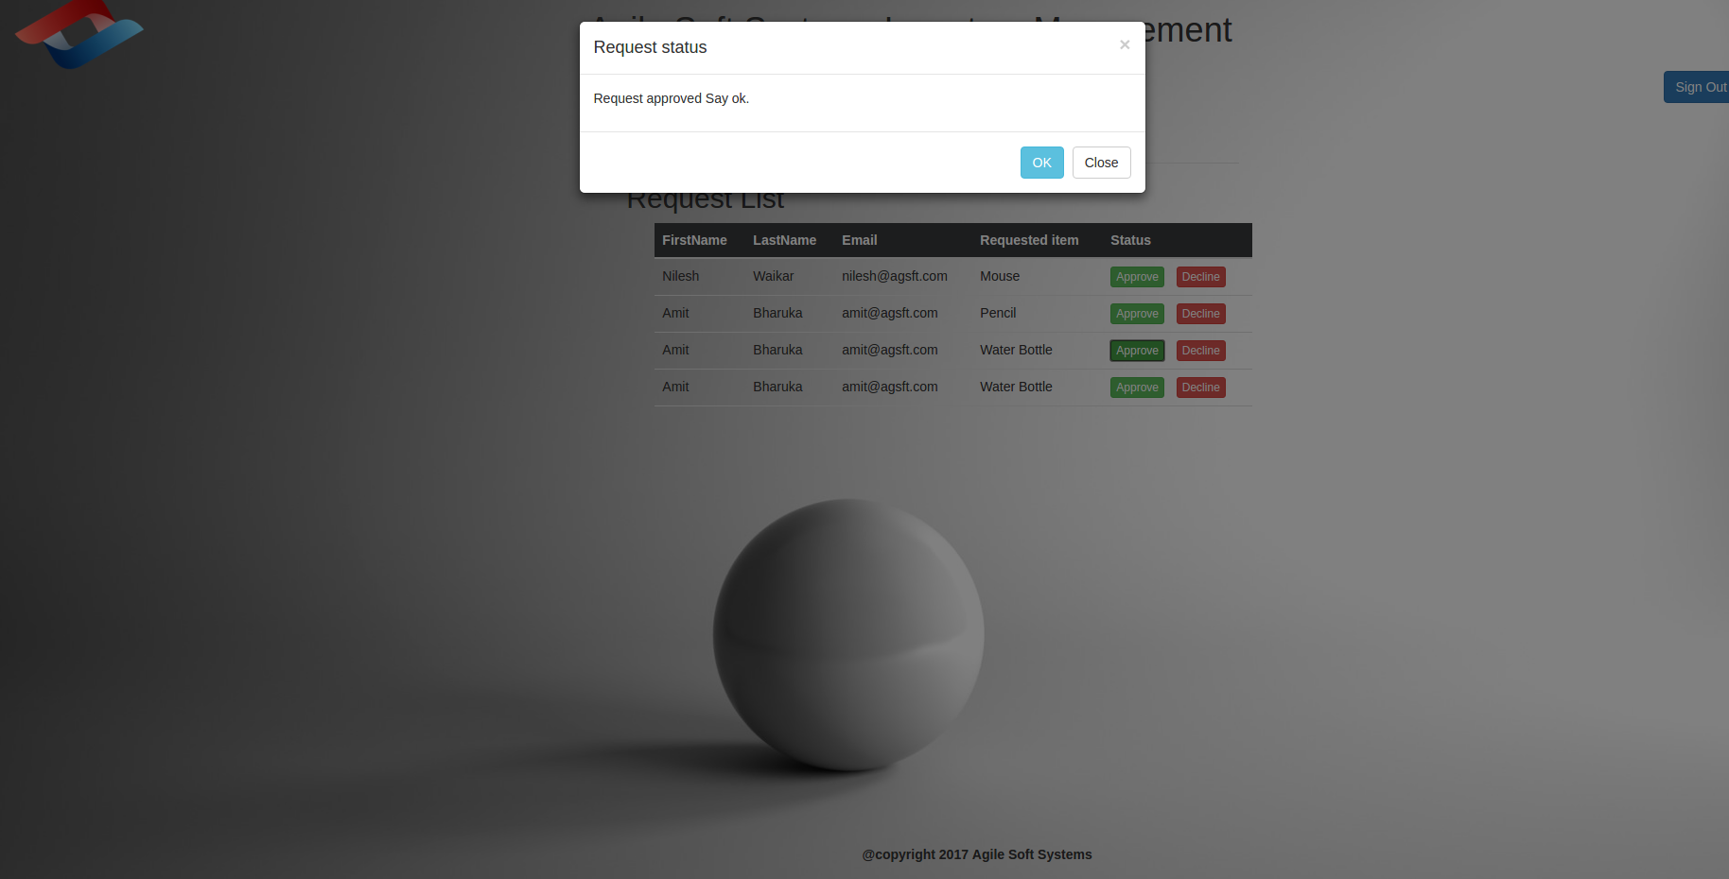

7.8 Sample User Home Screen

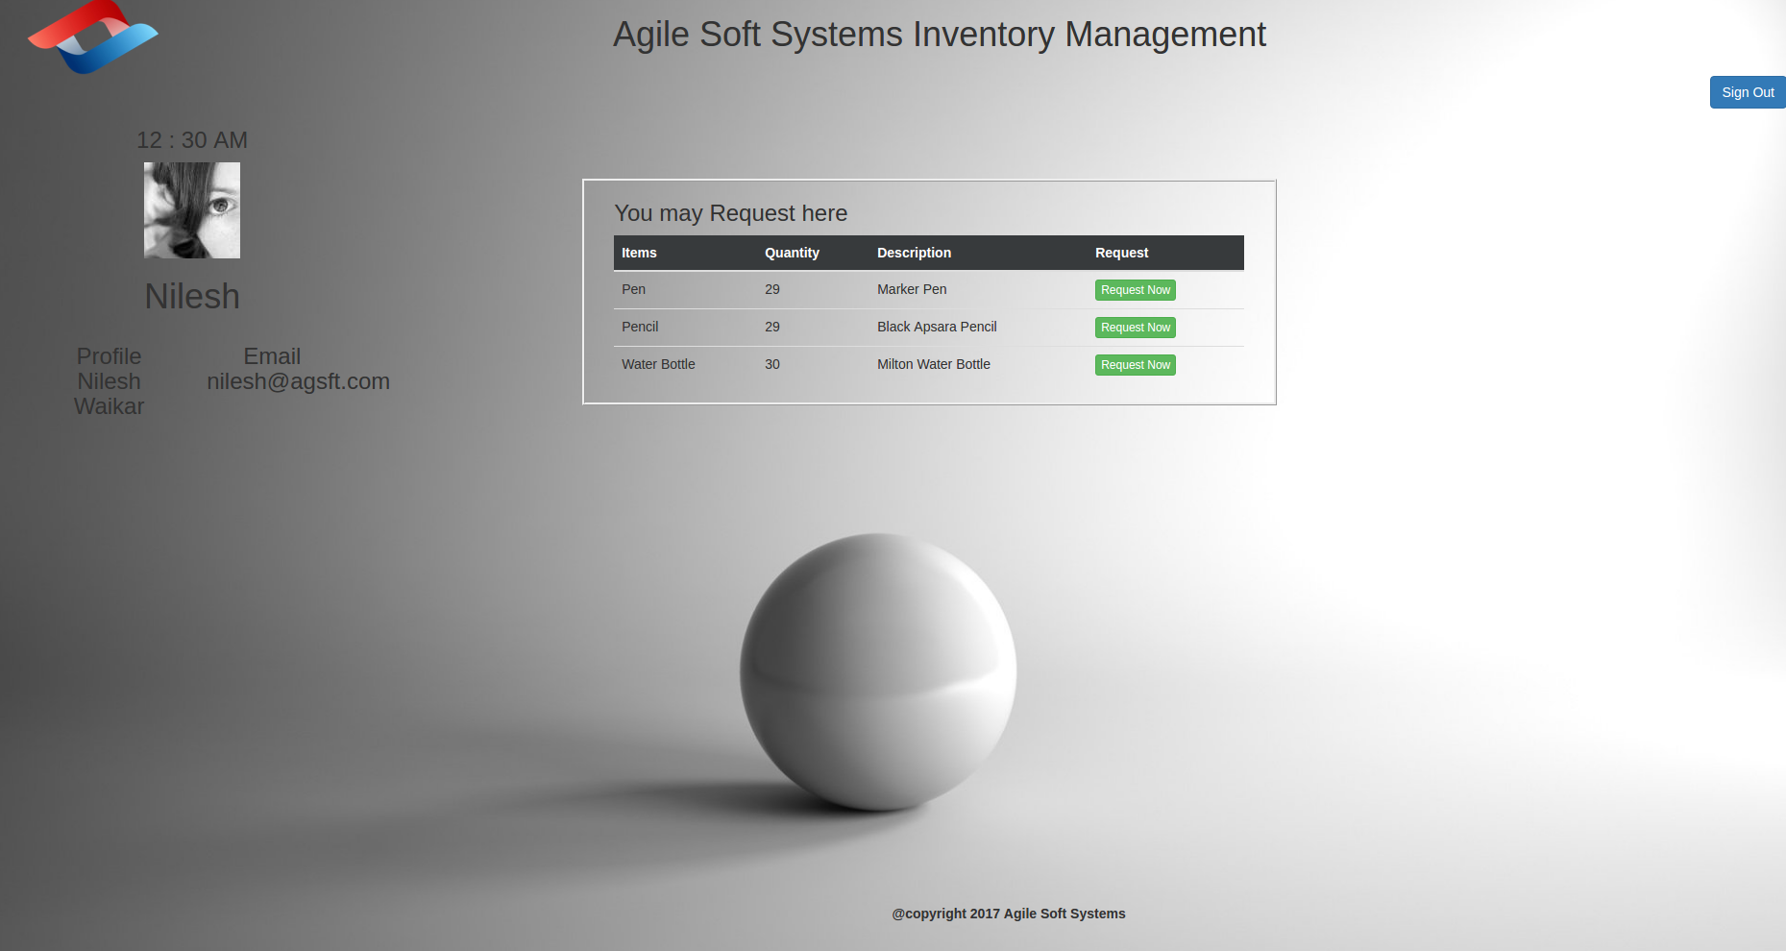
7.9 User's Request for a new item

Thank You.

